**Oracle APEX Automations**

To create automation:

1. Create a new application.
2. Navigate to the Automations page:
   1. On the Workspace home page, click **App Builder**.
   2. Select the new application.
   3. On the Application home page, click **Shared Components**.

The Shared Components page appears.

* 1. Under Workflows and Automations, select **Automations**.

The Automations page appears.

1. To create automation, click **Create**.

The Create Automations Wizard appears.

1. Specify the automation name and define the execution schedule:
   1. Name - Enter a name for the new Automation. For example, Increase SAL.
   2. Type - Select automation type. Select **Scheduled**.

**Scheduled** executes automatically based on the selected frequency. **On Demand** executes when called explicitly using the APEX_AUTOMATION package.

* 1. Actions initiated on - Select **Query**.

This option determines whether the execution of Automation Actions should be initiated based on a **Query** (that is, the rows returned can then be used by the actions), or if the actions should **Always** be executed.

* 1. Execution Schedule - Select an execution schedule for the new automation. Select **Custom**.

The **Frequency**, **Interval**, **Execution Minute** attributes only display if Execution Schedule is set to **Custom**.

* 1. Frequency - Specify whether the execution schedule should be based on a daily, hourly or minutely basis. Select **Hourly**.
  2. Interval - Enter 2 so that automation executes every 2 hours.
  3. Execution Minute - Specify the execution minute, from 0 to 59. Leave this to the default, 0.

The Create Automation Wizard should resemble the following illustration.

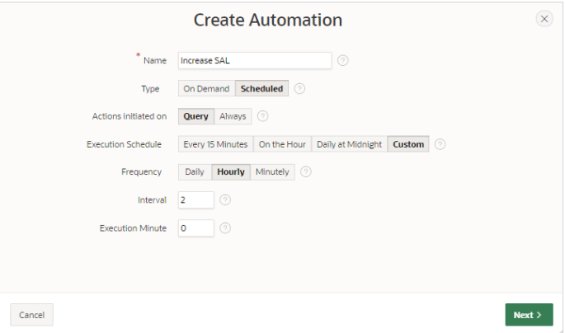

1. Define the source:

This example is based on the local table, EMP.

* 1. Data Source - Select the data source for this automation. Select **Local Database**.
  2. Source Type - Select **Table**.
  3. Table/View Owner - Select the owner of the table on which you are basing this automation.
  4. Table/View Name - Select the table or view on which the automation will be based. For this example, select **EMP (table)**.
  5. Execute Actions When - This option determines if Automation Actions should execute when the query returns rows, or when the query does not return rows. Select **Rows returned**.

The Create Automation Wizard should resemble the following illustration.

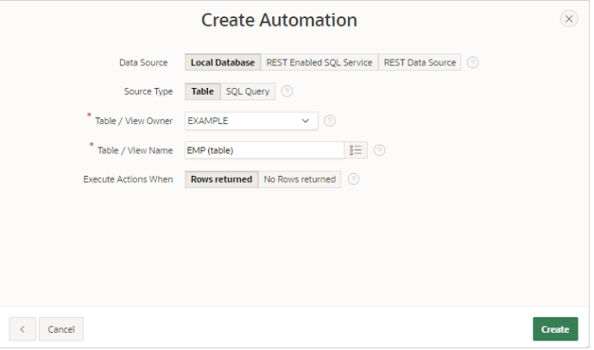

Click **Create**.

The automation edit page appears. The following message displays at the top of the page:

*Automation has been created and is in "Disabled" state. Now create Actions to execute when the automation runs*.

1. Edit the action for the first salary increase:
   1. Scroll down to **Actions**.

Note that the wizard created an action, named **New Action**.

* 1. Edit the new action, **New Action**:
     1. Click the **Edit** icon adjacent to **New Action**.

The Edit Action page appears.

* + 1. Name - Enter a meaningful name such as Increase SAL for SALESMAN.

The Edit Action page should resemble the following illustration.

**begin**

**update emp set sal = round(sal * 1.015, 1) where empno = :EMPNO;**

**apex_automation.log_info('SAL for ' || :ENAME || ' increased.');**

**end;**

* 1. Server Side Condition - Create a server side condition for the salary increase.
* Server Side Condition, Condition Type - Select **Expression**.
* Language - Select **PL/SQL**.
* Expression 1- Enter an expression to only execute the action when the salesman (SALESMAN) has a commission (COMM) of more than 500. Enter:

**:JOB = 'SALESMAN' and :COM > 500**

* Execute for Each Row - Enable this option to specify the condition execute for each row.
  + Click **Apply Changes**.

1. Run the automation. On the Automation Edit page, click **Save and Run**.

When you click **Save and Run**. The automations execute in the background. Note that the browser displays again immediately even if the actions are still running.

The following message appears:

*Changes applied. Automation Execution initiated.*